Linux server - Linux Basics and Networking

History & Evolution of Linux? Linux Distributions (Ubuntu, CentOS, Debian, RHEL)? Understanding CLI vs GUIPending

Tasks

1. Open the terminal on your system and run the command 'uname -a' to display your Linux kernel version and system information. Take a screenshot of the output.

ANS:

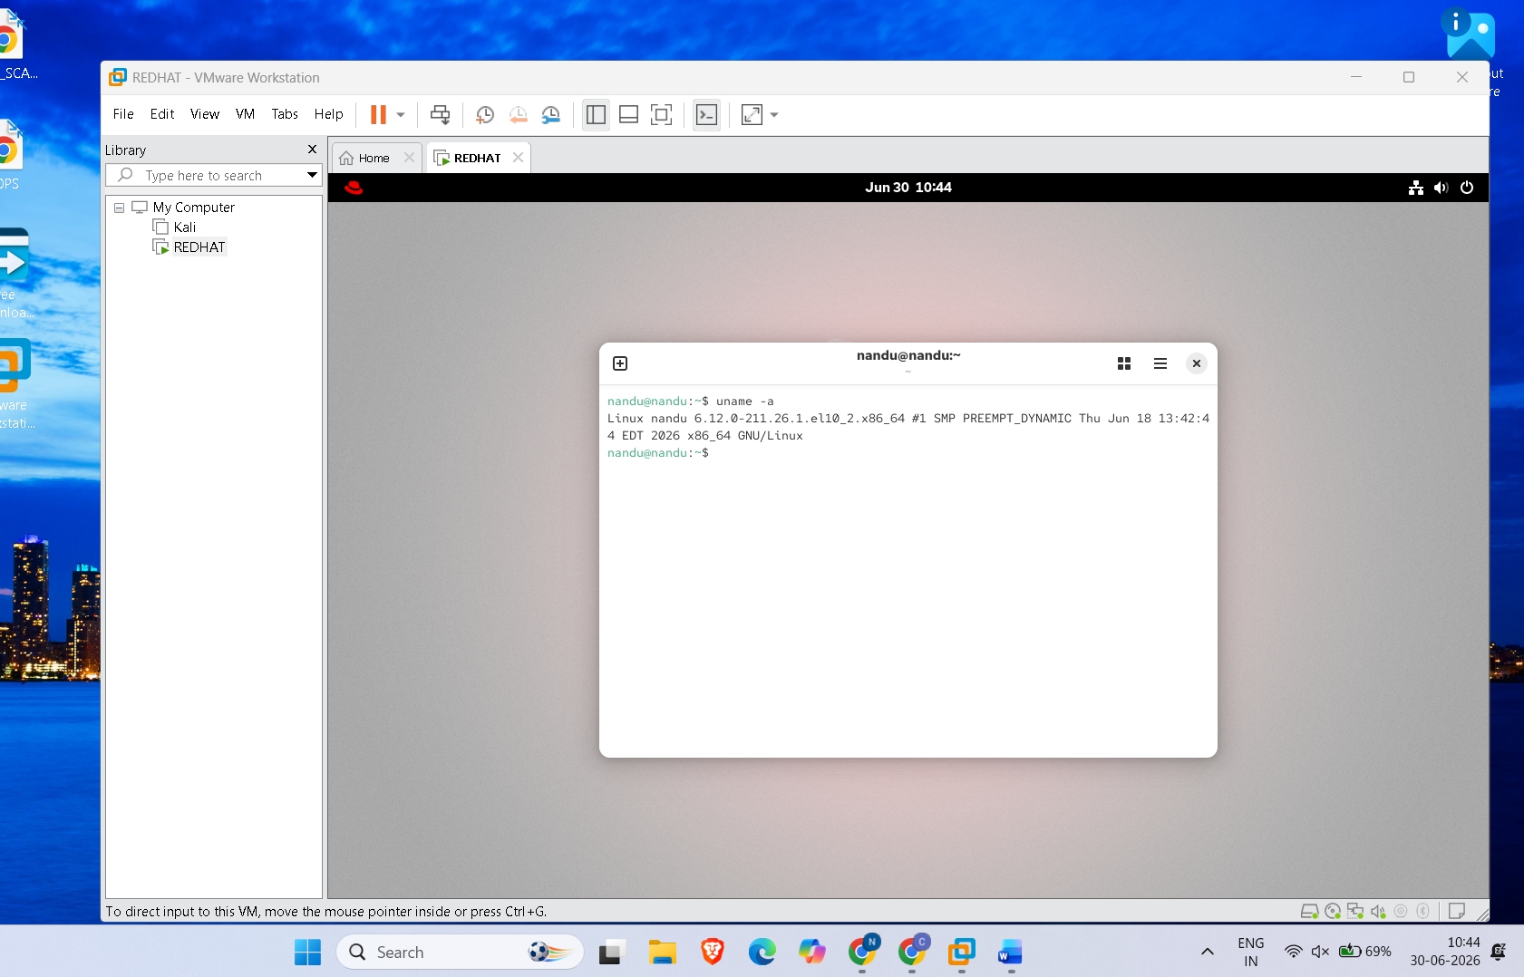

2. Research and list three key differences between Ubuntu, CentOS, and Debian Linux distributions, focusing on package management tools, default desktop environments, and typical use cases.

ANS:

Feature | Ubuntu | CentOS | Debian
Package Management Tool | APT (apt, dpkg) | YUM (older versions) / DNF (newer versions), RPM packages | APT (apt, dpkg)
Default Desktop Environment | GNOME | GNOME (Server editions usually have no GUI by default) | GNOME (official default, other desktop environments like KDE, XFCE, LXDE are available)
Typical Use Cases | Desktop computers, beginners, developers, cloud servers | Enterprise servers, web hosting, business environments | Stable servers, software development, advanced Linux users

Key Differences

- Package Management
  - Ubuntu: Uses APT for installing and managing software.
  - CentOS: Uses YUM or DNF with RPM packages.
  - Debian: Uses APT, similar to Ubuntu.
- Default Desktop Environment
  - Ubuntu: Uses GNOME with Ubuntu's customized interface.
  - CentOS: Uses GNOME when a graphical interface is installed; server installations are usually command-line only.
  - Debian: Uses GNOME by default but allows easy installation of KDE, XFCE, Cinnamon, and other desktop environments.
- Typical Use Cases
  - Ubuntu: Best for desktop users, beginners, developers, and cloud environments.
  - CentOS: Best for enterprise servers requiring long-term stability.
  - Debian: Best for highly stable servers and users who prefer a reliable, lightweight Linux distribution.

3. Switch between the CLI (terminal) and GUI (desktop environment) on your Linux system. Create a text file named 'my_linux_journey.txt' using both methods: first with the 'touch' command in CLI, then by right-clicking and creating a new text file in the GUI. Note which method you found faster and why.

ANS:

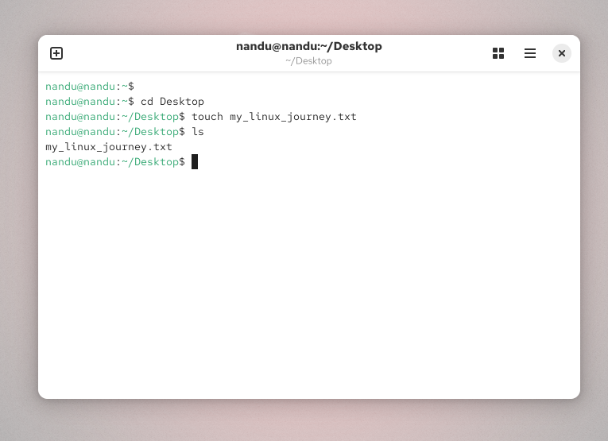

The CLI (Terminal) method was faster because I created the file with a single command:

touch my_linux_journey.txt

The GUI method took more time because I had to open the File Manager, right-click, select New Document, and enter the file name.

Conclusion: I found the CLI method faster because it is quick, efficient, and requires fewer steps than the GUI method.

4. Imagine you are helping a friend who only uses GUI apps like Spotify and Zomato on their phone. Write a short guide (5-6 lines) explaining why learning the Linux CLI can be powerful for tasks like installing software, managing files, or troubleshooting issues.

ANS:

The Linux Command Line Interface (CLI) is a powerful way to control your computer using commands instead of a mouse. It allows you to install software quickly, manage files and folders efficiently, and perform tasks faster than the GUI. The CLI is also very useful for troubleshooting system problems because it provides detailed information and powerful diagnostic tools. Many servers and cloud systems are managed through the CLI, making it an important skill for IT professionals. Learning basic Linux commands can save time and help you work more efficiently.

